Coursework cover sheet – be sure to keep a copy of all work submitted

Section A - To be completed by the student – PLEASE PRINT CLEARLY
Family Name(s)  CHAN |  |  | ModuleNo.  204KM
Forename(s)  YIK KIT |  |  | ModuleNo.  204KM
ID Number(s) (from your student card)  56237852 |  |  | ModuleNo.  204KM
Time taken (hrs) (per student for group coursework)  20 hours |  |  | Faculty Date Stamp  (or signature and date)
Lecturer  Albert Lau |  | Lab group / Tutorial group / Tutor (if applicable)  Group 1
Module Code and Title  204KM Operational Research |  | Due date: 6-Dec-2021
Assignment No. / Title
Small Scale Survey & OR Methods
Estimated Time (hrs)  20 hours | Assignment type: | % of Module Mark  60 | Hand out date:  Monday, week 3
Declaration: I / we the undersigned confirm that I/we have read and agree to abide by the University regulations on plagiarism and cheating and Faculty coursework policies and procedures. I / we confirm that this piece of work is my / our own. I / we consent to appropriate storage of our work for checking to ensure that there is no plagiarism/ academic cheating.
Signature(s): ---------Chan Yik Kit-----------

Section B - To be completed by the assessor
- Explain and apply various methods of data collection for diverse uses. Design, conduct, analyse, report and critically evaluate a small-scale sample survey.
- Model a range of situations for analysis by OR methods. Solve a range of business decision problems using appropriate software, analyse the output, and interpret the results in context.
Marks breakdown |  |  |  | Max | 1st marker | 2nd marker
Part A* (20% of module mark) |  |  |  | 100
 |  | * Penalty Due (A penalty of 10 marks will be applied for non-submission of List of References):  (Yes / No) |  | Penalty | Part A Mark | Part A Mark
Part B (40% of module mark)  Q1: Inventory control problem 1  Q2: Inventory control problem 2  Q3: Forecasting Models |  |  |  | 40  20  40
Assessor’s signature / initials: |  |  | Signed internal moderator: |  | Part B Mark | Part B Mark
Extension Agreed until:  Programme Leader Signature: |  |  | Final Coursework Mark  = (Part A Mark + 2 * Part B Mark) / 3 |  | Final CW Mark | Final CW Mark
This work may have been moderated. You may find additional comments in the work.
This section may be used for feedback or other information

204KM Assignment Rubric for part A (/50)
Criteria (/50) | F  Below 40% | D  40-49% | C  50-59% | B  60-69% | A  Above 70%
Introduction (includes environmental context, research problem statement, aim(s) & objectives) (/10) | Primarily a list of facts, both relevant and irrelevant. Lacks coverage of key areas. Little connections between facts. Research aims & objectives are unclear and/or irrelevant. | Presents relevant and irrelevant facts. Some key areas of analysis missing. Some evidence of connections between the facts. Research aims & objectives are not entirely clear and sometimes irrelevant. | Presents mostly relevant facts, covers most of the important areas. Good integration of facts. Research aims & objectives are mostly clear and generally relevant. | Thorough and insightful, and includes mostly relevant facts. Very good demonstration of integration. Research aims & objectives are clear, relevant, and specify desired end states. | Remarkably thorough and insightful. Only relevant facts are superbly integrated to present a comprehensive overview of situation. Research aims & objectives are entirely clear, extremely relevant, and clearly specify desired end states.
Sampling strategy (/5) | Methodology described with minimal detail and justification for sampling strategy is weak. | Methodology described with some detail and sampling strategy is only partially justified. | Most of methodology described in good detail, and justification for sampling strategy is good. | Accurate detail provided for majority of methodology and sampling strategy is well justified. | Methodology described in extensive and accurate detail and sampling strategy is extremely well justified.
Questionnaire Design (/10) | The reader cannot identify a line of reasoning and loses interest. Questionnaire does not meet criteria defined; lacks insight, thoughtfulness, and creativity. | The reader is fairly clear about what writer intends. Only partially meets criteria defined; shows some insight, thoughtfulness, and creativity. | For the most part, the reader can follow the line of reasoning. Meets the criteria defined; demonstrates good insight, thoughtfulness, and creativity. | The reader can follow the line of reasoning. Does a very good job of meeting the criteria defined; demonstrates very good insight, thoughtfulness, and creativity. | It sustains interest throughout. Meets the criteria defined very well; is exceptionally insightful, thoughtful, and creative.
Findings and Discussion (/10) | Analysis is often inaccurate, lacks insight, and/or is described in insufficient detail. | Analysis is partially accurate, demonstrates limited insight, and/or described in minimal detail. | Analysis is mostly accurate, demonstrates some insight, and/or described in adequate detail. | Analysis is mostly accurate, quite insightful, and/or thoroughly described. | Analysis is entirely accurate, demonstrates exceptional insight and understanding, and/or is described in excellent detail.
Conclusions (/10) | Conclusions described with minimal detail. Disconnected from objectives, and research findings. | Conclusions described with some detail. Loosely connected to objectives, and research findings. | Most of the conclusions described in good detail. Partially connected to objectives, and research findings. | Very good detail provided for majority of conclusions. Well connected to objectives, and research findings. | Each conclusion element described in extensive detail. Extremely well connected to objectives, and research findings.
Critical Evaluation (/5) | Evaluation lacks insight, thoughtfulness, and creativity. | Evaluation shows some insight, thoughtfulness, and creativity. | Evaluation demonstrates good insight, thoughtfulness, and creativity. | Evaluation demonstrates very good insight, thoughtfulness, and creativity. | Evaluation is exceptionally insightful, thoughtful, and creative.

Table of contents
Part A – Small Scale Survey
Section 1: Introduction……………………………………………………………………………………...P.4
Section 2: Research Methodology…………………………………………………………………………..P.4
Section 3: Findings and Discussion…………………………………………………………………………P.5
Section 4: Conclusion…………………………………………………………………………..………….P.13
Section 5: Critical Evaluation of the overall process – self-reflection…………………………………….P.14
List of References…………………………………………………………………………………………P.15
Appendix 1: Questionnaire……………………………………………………………………………....P.16
Part B: Analysis by OR methods
Question 1……………………...………………………………………………………………………….P.18
Question 2…………………………………………………………………………………………...…….P.22
Question 3……………………………………………………………………………………………...….P.23

Part A: Small Scale Survey
Section 1: Introduction
A canteen is a location where food and beverages are sold. Every canteen has a responsibility to supply customers with high-quality food, prompt service, and hygienic practices (Galabo 2019). Students are the main customers of the school canteen, and it is the school's responsibility to assure their health, convenience, and learning experience during their school years. Generally, school canteen is characteristics to be located at school for convenience, provides hot and suitable meals for students, teachers and related customers.
Sometimes, there is some news showed that school canteen provided low service quality or received complaints of food qualities, for instance, a too-small portion of foods, too expensive, etc, which affect student's likelihood to eat in the school canteen. To keep high quality for foods and services is very important for a school canteen. Customer satisfaction is an assessment of a product's or service's ability to meet the customer's expectations. Satisfaction refers to the good sensation that an individual has when his or her wishes, expectations, or requirements are met (Galabo 2019).
City Express is the main food outlet at the City University of Hong Kong, and it is run by the Café de Coral Group. It is where the majority of students and employees eat. Breakfast, lunch, afternoon tea, supper, and snacks are all available. Food is offered in both Western and Asian styles.
This survey aims to find out the service quality level and overall customer experience level from a designed questionnaire about school canteen service qualities, food qualities and customer experience. By the result of the survey, to find out the recent situation and weaknesses of the service of City Express.
Section 2: Research Methodology
The survey design by references as following:
According to a reference like the research from the Lyceum International Maritime Academy (LIMA) Campus (Veron & Caiga 2015), it aims to gain insights on the level of satisfaction of students in Campus on the services rendered by its Canteen, and their study would determine the level of satisfaction on the current services that are rendered by the canteen, as well as propose solutions to the problems that are cited. They used a descriptive study technique with (240) school students who were selected using a random sample process. Also, reference to the design of this essay from Indonesia (Azni, Giyatmi & Amelia 2019), it defined school canteen’s characteristics, service qualities and general customer expectation of school canteen. And these help to design a descriptive study for research on City Express.
The questionnaire was designed in 5 parts: basic information, service items, the overall level of satisfaction with City Express, behavioral intentions and, demographic and classification questions. The basic questions and the demographic and classification questions were designed to classify the strict groups and filter unsuitable respondents to process for the following analysis. The main response targets are CityU students who have visited City Express in the past 2 months. In addition, the medium parts are for collecting data of service qualities and customer experience for City Express.
Due to the recent situation of COVID-19 in Hong Kong, an online questionnaire survey was issued using the snowball technique of data collecting. I disseminated the questionnaire which designing in QuestionPro to 5 CityU students I knew and requested them to share the link with another 2 CityU students, like snowballing. Finally, I obtained 31 useful replies that I may utilize in the next analysis, which were filtered and sorted into 39 responses.
Section 3: Findings and Discussion
The duration of collecting the data is a total of a month. The questionnaire is designed by using the QuestionPro and distributed in snowball method. Finally, I obtained 31 useful replies that I may utilize in the next analysis, which were filtered and sorted into 39 responses. The not in use responses were like not answering all questions, not CityU student in the past 2 months, or having not visited City Express in the past 2 months. It is processed to analysis in Mircosoft Excel for all collected data.
The below table shows the respondent’s information in a profile. By exporting to Mircosoft Excel and classifying the collected data, there are a total of 16 male and 15 female respondents which almost half-half responses in useful responses. For the age, there are 19.35% respondents aged below 20 while 74.19% respondents aged between 20 to 29 and 6.45% respondents aged between 30 to 39, in addition, there are on respondents aged 40 or above. For the education level of respondents, there are 77.42% studies in bachelor degree, 16.13% studies in the associate degree in the City university of Hong Kong while there are 2 respondents who responded that they in secondary school or below whose studies in some short-term course in the City University of Hong Kong. It results that, the gender of respondents is balanced and they are mainly aged between 20 to 29 studying in bachelor degree in the City University of Hong Kong and visited City Express in the past 2 months.
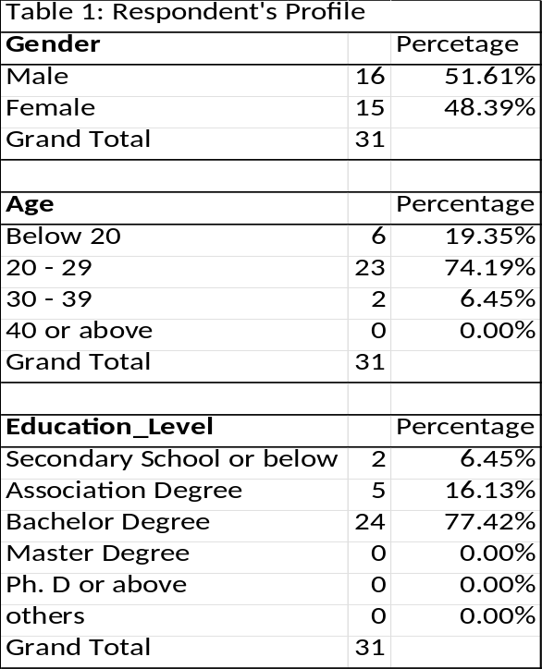
Below table 2 shows the respondent’s rating of service on the level of importance. The highest mean is 4.16 of the hygiene condition of City Express. The lowest mean is 3.45 of the service items: canteen appearance or decoration and health of food. It results that students take high awareness of the hygiene condition during the occurs of COVID-19 includes school canteen (restaurant). In the food service industry, hygiene is paramount. Because it had anything to do with food safety. There are several aspects that contribute to food safety, including raw material sources, food processing, storage and handling methods, and the people who are engaged in the process (Manzano 2013). Foodborne illness can be spread by poor food handling cleanliness. The degree of client satisfaction with City Express's cleanliness is still low. The food handler at City Express has to pay attention to this situation. All mean figures including the lowest means are above the average of questions (3 is the neutral/fair) which means that respondents thought all service items are more likely to be important than not. In addition, the standard deviation also shows that only those two lowest means are more spread out in responses data.
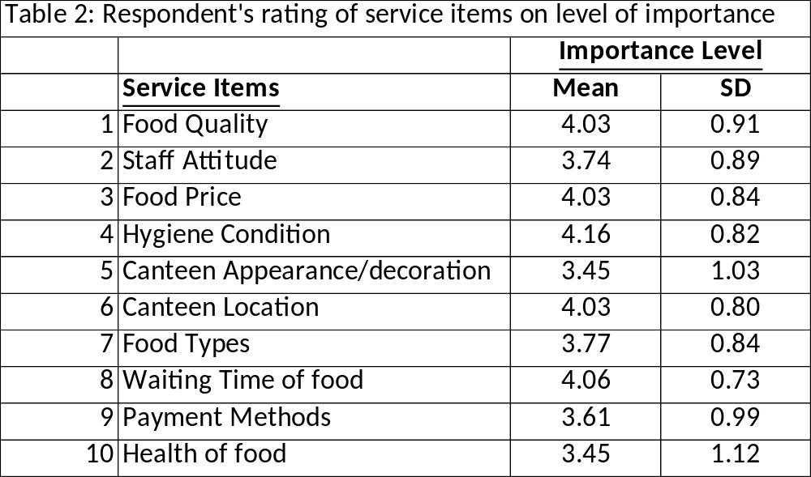
Below table 3 shows the respondent’s rating of service items on expected performance level and perceived performance level, all service gaps are highlighted in red as the negative figures. Those service gaps in red result in the service item which needs to be improved as it did not meet respondents’ expected performance level when they perceived it during dining in City Express. Service gaps are found out by average perceived value minus average expected value of a service item. The most negative figure of service gap is -1.16 of “Canteen Staff should have good personal hygiene”, which shows that the “hygiene condition” is the biggest difference gap between respondent’s expected performance and perceived performance.
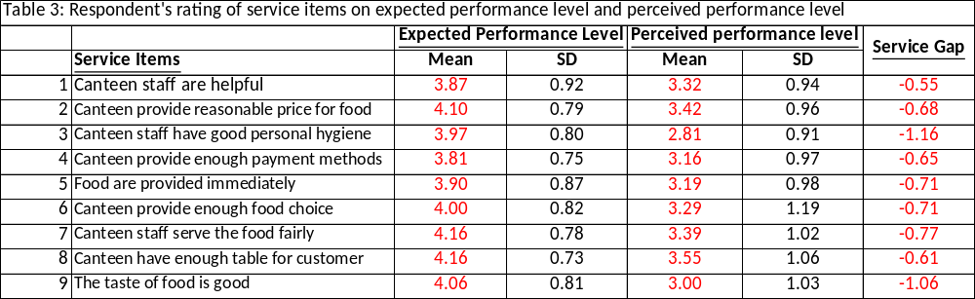
Importance-Performance Analysis
Below tables and the importance performance chart shows the average figures of importance level and perceived performance level and each quadrant requires a different approach and strategy (Wyród-Wróbel and Biesok, 2017). Referring to the below results, service item "Food price" placed in quadrant 1 which is the major strength of City Express, should keep the quality in this stage. There are 3 service items: "canteen appearance or decoration", "staff attitude" and "food types", places in quadrant 2 which are main items for City Express to increase their service quality by changing those service item's operation strategy. Moreover, quadrants 3 and 4 are under the overall mean of the performance and importance rating which clearly show the weaknesses of those service items of City Express's service level. Besides, service item "payment methods" is in quadrant 3, it is advised that City Express does not need to take too much care on this item as it has low importance compared to the above 2 quadrants. Lastly and the most important to make improvements as soon as possible are those service items: "waiting for the time for food", "food quality" and especially "hygiene conditions" in the quadrant 4, they have high importance but low performance in results. These are City Express's significant flaws, which must be addressed immediately to improve customer happiness and reduce turnover.
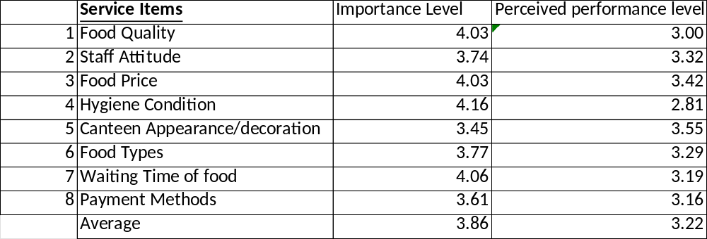
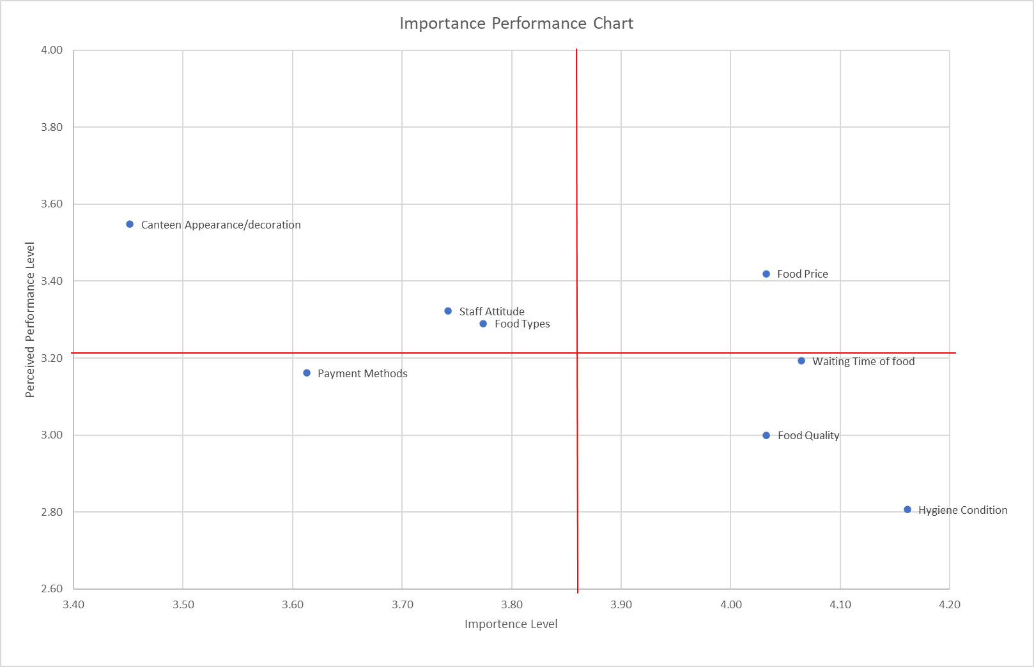
Distribution of Overall Satisfaction Level
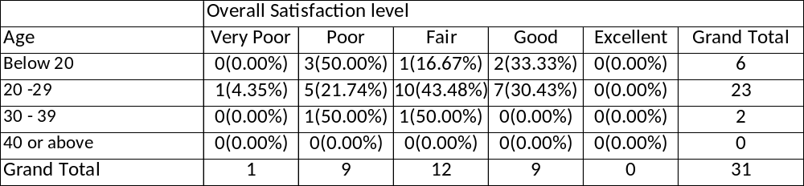
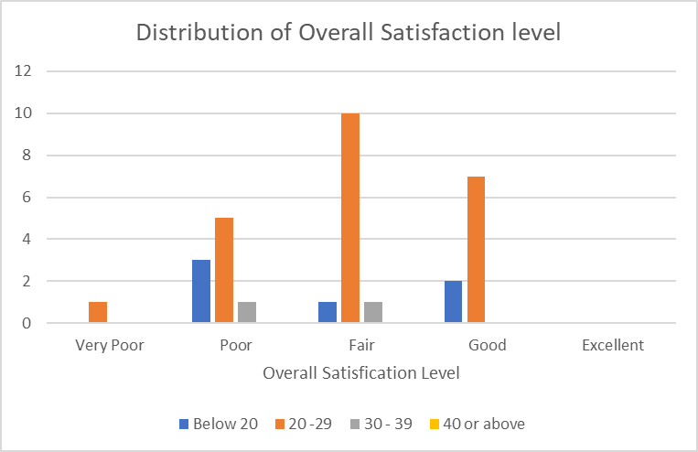
The above shows a bar chart of the distribution of customers’ overall satisfaction level on City Express, it is a 0% as there are no respondents aged 40 or above, most of the candidates having high overall satisfaction levels are aged between 20 to 29 as they are mainly studies in the campus which have a higher probability to dine in City Express. Therefore, as the results showed that respondents aged between 20 to 29 are the most satisfied with the overall level of dining in City Express. However, there is no one who feels an excellent overall satisfaction level which means that City Express needs to improve those service items.
Distribution of Behavioural Intentions
Visit Likelihood Level
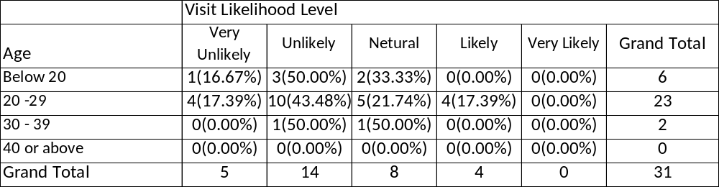
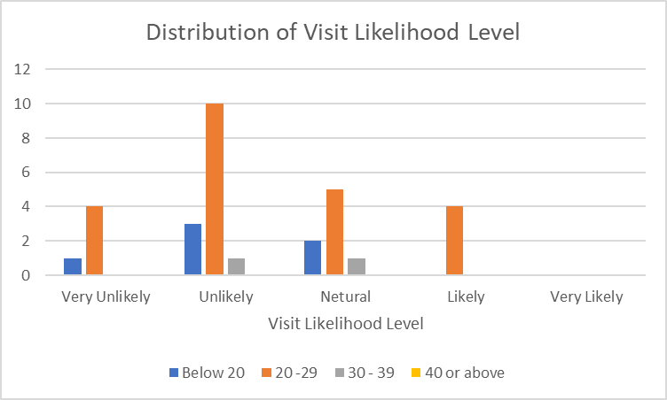
The above graphs show the distribution of customers' loyalty to City Express based on their visit likelihood level; there are no respondents aged 40 or older, and most of the respondents aged 20 to 29 feel unlikely to visit City Express because they are primarily students on campus who have a higher probability of always dining in City Express in a short period of time, making them feel unlikely to visit in the same restaurant. Also, there are some of the respondents who feel netural (second rank in the chart), to visit City Express again. As a result of the findings, the majority of respondents believe that dining at City Express is improbable.
Recommend Likelihood Level
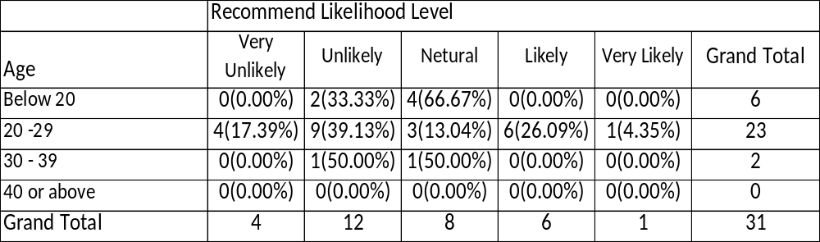
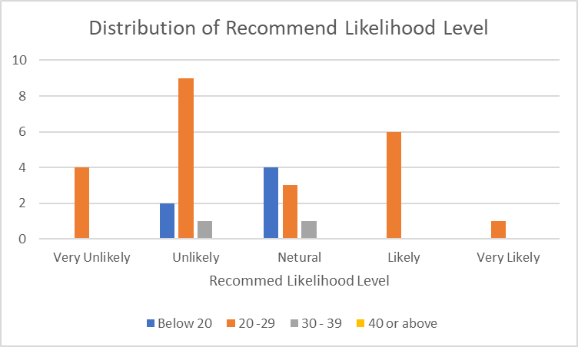
The above graphs show the distribution of customers' loyalty to City Express based on their recommended likelihood level; it is a 0% as there are no respondents aged 40 or above, and most of the respondents aged 20 to 29 feel unlikely to recommend City Express to their friends or others while some of them feel netural to recommend the school canteen. At the same time, there are 6 respondents who feel likely to recommend, 4 of them feel very unlikely and only one of them feels very likely. The distribution spread out a wide range which results that respondents are having different feelings of services or foods of City Express.
Visit Frequency
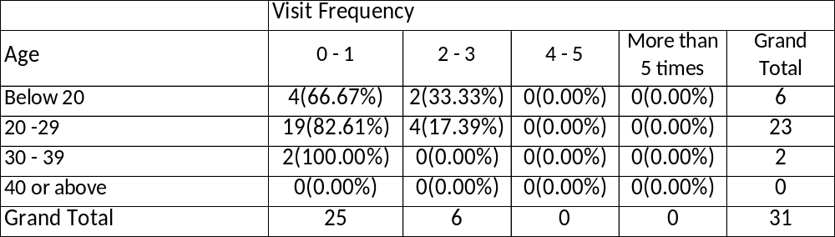
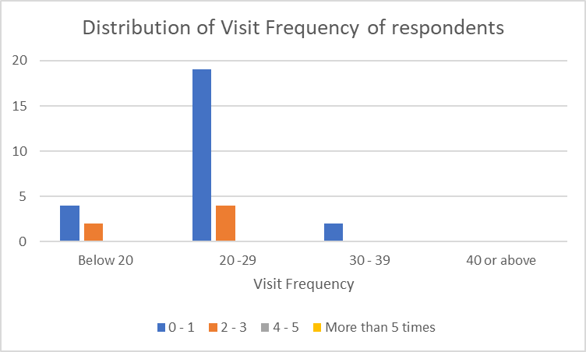
The graphs above demonstrate the distribution of customer loyalty to City Express based on visit frequency; it is a 0 percent since there are no respondents aged 40 or older, and most of the respondents only visited City Express 0 to 1 time in the previous 2 months. At the same time, 6 respondents said they had visited City Express 2 to 3 times in the previous 2 months. As a result of the findings, respondents visit City Express less frequently, with the majority only visiting once or zero times in two months.
Section 4: Conclusion
First and foremost, after being categorised, the gender of respondents in the survey is balanced, with the majority of respondents being between the ages of 20 and 29, studying bachelor's degrees at the City University of Hong Kong, and having visited City Express in the previous two months. As shown by the preceding data, students are very concerned about hygiene during COVID-19, which includes the school canteen (restaurant), and they believe that all service elements are more significant than not. The "hygiene condition," on the other hand, is the highest discrepancy between respondents' predicted and perceived performance.
Secondly, according to results, the key strength of City Express is its food pricing, which should be maintained at this point. Furthermore, it is recommended that the operating strategy for those service items that include "canteen appearance or decoration", "staff attitude," and "food types" be changed, since these are key elements for City Express to improve their service quality. Furthermore, City Express is urged not to place too much emphasis on "payment methods" because it has a minor impact on the outcome. Finally, and most importantly, those service items: "waiting time for food," "food quality," and notably "hygiene conditions," all of which have great relevance but low performance in terms of outcomes, should be improved as quickly as feasible. These are City Express's major faults, which must be solved right now in order to increase customer satisfaction and lower turnover.
Third, for the element of overall satisfaction level, in distributions of Behavioural Intentions, the results revealed that respondents aged 20 to 29 are the most satisfied to dine in City Express. However, no one expresses a high degree of overall satisfaction, suggesting that City Express has to enhance those service elements. As a consequence of the degree of visit likelihood, the majority of respondents felt that dining at City Express is unlikely. The distribution spanned across a broad range for the suggested likely level in the recommended likelihood aspect, resulting in respondents having various views about City Express's services or cuisine. Quality is a tough notion to describe since it signifies various things to different individuals. In other words, how one client experiences a product or service may differ from how another customer experiences it. Quality may be classified from a variety of viewpoints, such as product evaluation. The quality of a thing cannot be defined from the standpoint of judgment, but it may be identified. The user viewpoint is concerned with how a customer's demands are met (Evans 2011). City Express is visited less frequently by respondents, with the majority only visiting once or zero times in two months. When it comes to consumer visit frequency, respondents visit City Express less frequently, with the majority visiting either once or zero times in the previous two months.
In conclusion, City Express failed to meet the main customer – students' expected service level – when they evaluated services from City Express staff and meals during the preceding two months. Integrated to say and in suggestion, City Express has to improve such service items as quickly as possible, based on the survey results, in order to make a better decision that will increase their productivity and provide them a competitive edge.
Section 5: Critical Evaluation of the overall process – self-reflection
In this task, I discovered my talents in organizing a campaign and soliciting assistance from classmates. I have solid relationships at school, which encourages peers and classmates to participate in the questionnaire, allowing me to collect data on City Express deliveries.
Also, I believe I need to enhance my analyzing abilities and method design because the language of several questions is not correct or well-written, causing difficulty in analyses. More practice with analysis and research methodologies, particularly questionnaire designs, is required. Because I was the sole person in charge of survey preparation and design, I used my project management abilities to practice time management, section breaking, and data collection.
During this survey preparation, as the size of the survey is too small, respondents like only 30 something which may harm the accuracy problem of the collected data, therefore I have to sort those data clearly and carefully, especially the distribution of different aspects for City Express. In addition, I achieved to collect the data by questionnaire in a nice time manner which helped my progress on survey analyses and timely error reduced as the survey is designed for the past 2 months of service from City Express.
It's great to have completed the questionnaire data gathering on schedule, and the findings are evident. However, some respondents only completed around half of the questionnaire, or other respondents are not completing out the questionnaire in a systematic manner, causing the data to be erroneous. I was disappointed, but these are issues I need to address in survey design and management.
Last but not least, I believe there are still many parts of survey management, questionnaire design, and data analysis that I need to learn and improve on; I will do better in the future in those areas to generate a better survey.
List of References
Azni, I. N., Giyatmi, G., & Amelia, J. R. (2019, November). ‘Study Of Customer Satisfaction At Canteen Of Sahid University–Jakarta’. ICCD, Vol. 2, No. 1, pp. 627-631.
Evans JR. (2011). “The management and control of quality”, South-Western-Cengage Learning (USA), (Edisi ke-8.).
Galabo NR. (2019). “Canteen service quality and student satisfaction”. International Journal of Scientific & Technology Research, 8(6),114-26.
Manzano AI. (2013). “Competency-based modules in food sanitation and safety”. International Journal of Academic Research in Business and Social Sciences, 3(8),142-55.
Veron, M. R. B., & Caiga, B. T. (2015). “Maritime Students’ Satisfaction on the Services Rendered by the Canteen”. Asia Pacific Journal of Maritime Education, 1(1).
Wyród-Wróbel, J. and Biesok, G. (2017) ‘Decision making on various approaches to Importance-Performance Analysis (IPA)’. European Journal of Business Science and Technology 3(2), 123-131
Appendix 1: Questionnaire
Welcome Message
Hello, I am a final year student of City University of Hong Kong.

In order to provide better catering service in City Express – the biggest student canteen in City University, I am now inviting you to participate in the survey of City Express service quality research. It will take approximately 5 minutes to complete the questionnaire.

Your survey responses will be strictly confidential and data from this research will be reported only in the aggregate. Your information will be coded and will remain confidential.

Thank you very much for your time and support. Please start with the survey now by clicking on the Continue button below.

Part A: (Basic Information)
Q1. Are you a student of CityU?
Yes □ 1
No □ 2
Q2. Have you visited City Express in the past 2 months?
Yes □ 1
No □ 2

Part B: Service Items
Importance of the service items:
Q3 How important are the following services items offered by student canteen? (Level of importance)
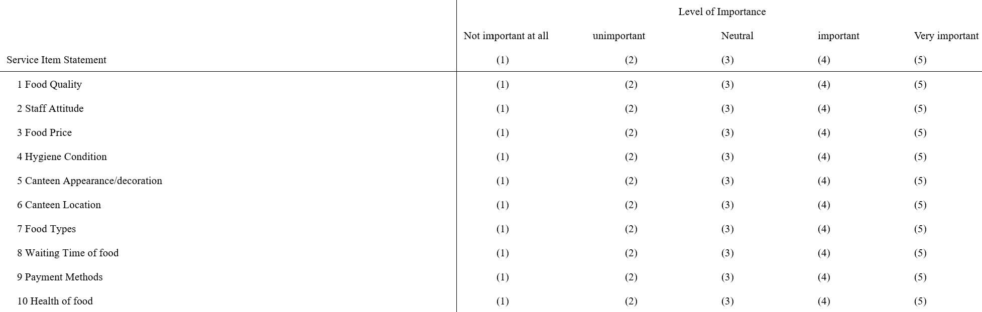Q4 How far do you agree with the following student canteen service statements? (Expected level of quality of each item offered by student canteen)
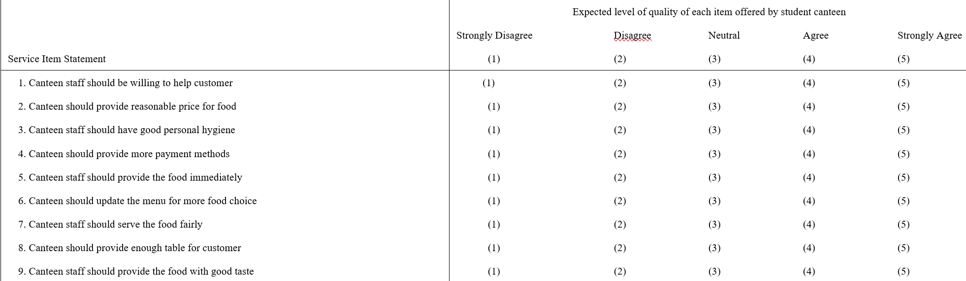Q5 How far do you agree with the actual performance of the following service items offered by City Express?
(Perceived level of quality of each item offered by City Express)
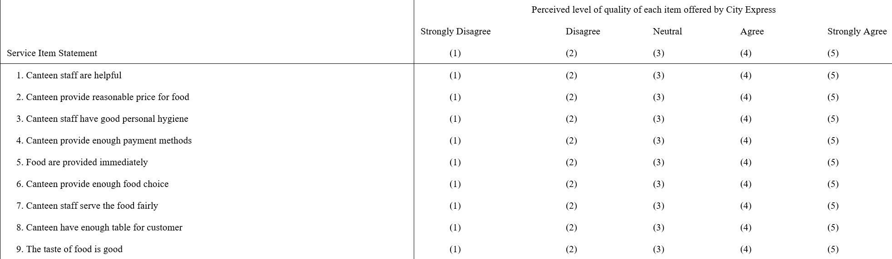
Part C: The overall level of satisfaction with City Express
Q6. Overall, how satisfied are you with the City Express?
1 (very dissatisfied) 2 3 4 5 (very satisfied)

Part D: Behavioral intentions
Q7. Q7 How likely are you visit to City Express?
1 (very unlikely) 2 3 4 5 (very likely)
Q8. How likely are you to recommend City Express to your friends/others?
1 (very unlikely) 2 3 4 5 (very likely)

Part E: Demographic and Classification Questions
Q9. Gender
Male □ 1
Female □ 2

Q10. Age
Below 20 □ 1
20 - 29 □ 2
30 - 39 □ 3
40 or above □ 4

Q11. Education Level
Secondary School or below □ 1
Association Degree □ 2
Bachelor Degree □ 3
Master Degree □ 4
Ph. D or above □ 5
others □ 6

Q12. How often do you visit City Express per week?
0 – 1 time □ 1
2 – 3 times □ 2
4 – 5 times □ 3
More than 5 times □ 4

Part B: Analysis by OR methods
Q1
a) (referred to attach Excel file – Part B Q1)
Determine the economic order quantity Q*.
Annual Demand (D) = 20000
Ordering Cost (Co) = 2000 per order
Holding Cost % of purchase price (I) = 15% (0.15)
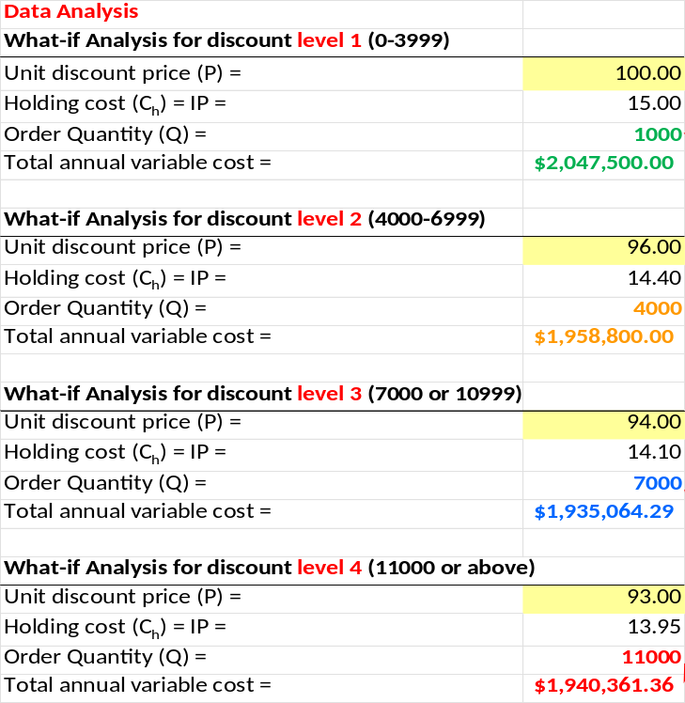
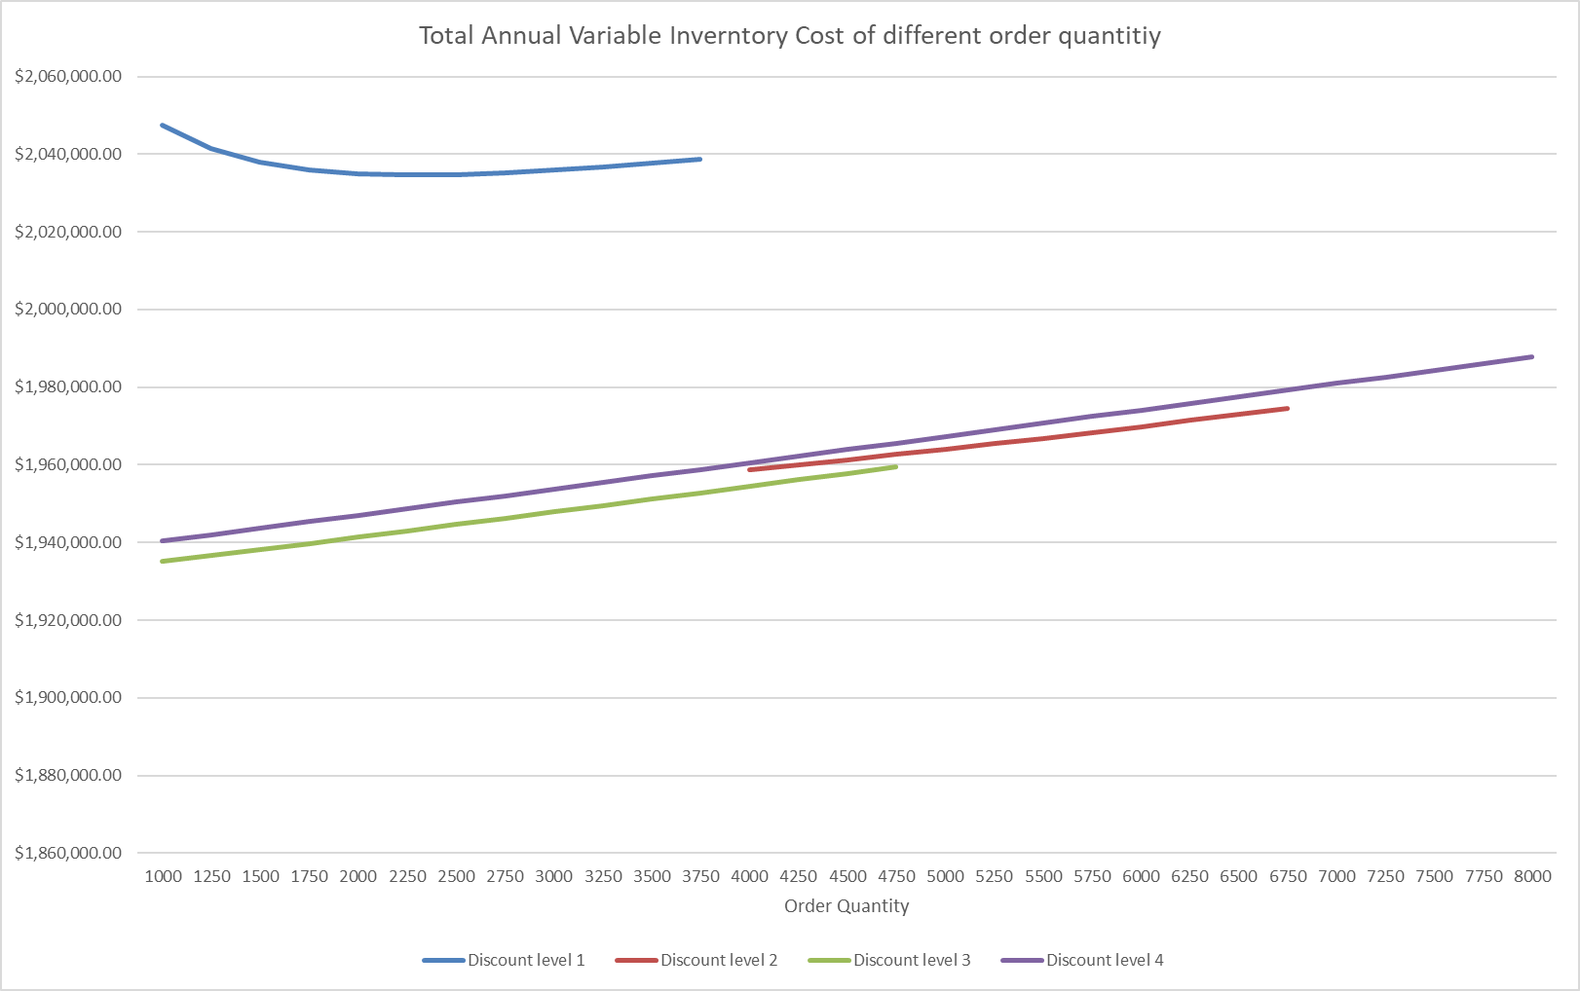
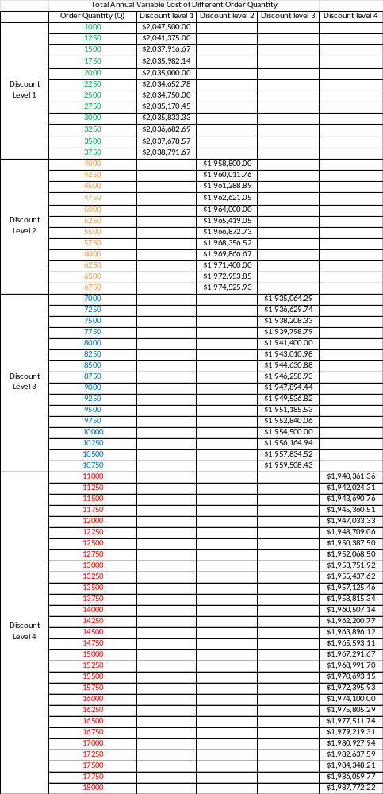
b)
Raw Data
Annual Demand (D) = | 23000
Ordering cost (Co) = | 2000
Holding Cost % of purchase price (I) = | 0.15
Data Analysis
What-if Analysis for discount level 1 (0-3999)
Unit discount price (P) = | 100.00
Holding cost (C_{h}) = IP = | 15.00
Order Quantity (Q) = | 1000
Total annual variable cost = | $2,353,500.00
What-if Analysis for discount level 2 (4000-6999)
Unit discount price (P) = | 96.00
Holding cost (C_{h}) = IP = | 14.40
Order Quantity (Q) = | 4000
Total annual variable cost = | $2,248,300.00
What-if Analysis for discount level 3 (7000 or 10999)
Unit discount price (P) = | 94.00
Holding cost (C_{h}) = IP = | 14.10
Order Quantity (Q) = | 7000
Total annual variable cost = | $2,217,921.43
What-if Analysis for discount level 4 (11000 or above)
Unit discount price (P) = | 93.00
Holding cost (C_{h}) = IP = | 13.95
Order Quantity (Q) = | 11000
Total annual variable cost = | $2,219,906.82

Raw Data
Annual Demand (D) = | 26000
Ordering cost (Co) = | 2000
Holding Cost % of purchase price (I) = | 0.15
Data Analysis
What-if Analysis for discount level 1 (0-3999)
Unit discount price (P) = | 100.00
Holding cost (C_{h}) = IP = | 15.00
Order Quantity (Q) = | 1000
Total annual variable cost = | $2,659,500.00
What-if Analysis for discount level 2 (4000-6999)
Unit discount price (P) = | 96.00
Holding cost (C_{h}) = IP = | 14.40
Order Quantity (Q) = | 4000
Total annual variable cost = | $2,537,800.00
What-if Analysis for discount level 3 (7000 or 10999)
Unit discount price (P) = | 94.00
Holding cost (C_{h}) = IP = | 14.10
Order Quantity (Q) = | 7000
Total annual variable cost = | $2,500,778.57
What-if Analysis for discount level 4 (11000 or above)
Unit discount price (P) = | 93.00
Holding cost (C_{h}) = IP = | 13.95
Order Quantity (Q) = | 11000
Total annual variable cost = | $2,499,452.27

Q2
a)
Weekly demand | Probability | Probability that demand will be at this level of greater
56 | 0.10 | 1.00
57 | 0.10 | 0.90
58 | 0.05 | 0.80
59 | 0.05 | 0.75
60 | 0.10 | 0.70
61 | 0.05 | 0.60
62 | 0.05 | 0.55
63 | 0.10 | 0.50
64 | 0.05 | 0.40
65 | 0.05 | 0.35
66 | 0.10 | 0.30
67 | 0.05 | 0.20
68 | 0.05 | 0.15
69 | 0.05 | 0.10
70 | 0.05 | 0.05
Step 1: Marginal Loss / (Marginal Loss + Marginal Profit) = 0.2222
Step 2: Prob (Demand ≥ 66) = 0.30 which is slightly greater than 0.2222
Therefore, the optimal number of copies produced Q* is 66

b)
Step 1: ML/(ML + MP) = 2/(2+7) = 2/9 = 0.2222
Step 2: Consider area ≤ 0.7778, Z value is 0.76
Q* = average sales vol. + Z * standard deviation (where Z is 0.76 from standard normal table)
Q* = 66 + Z (12)
Q* = 66 + 0.76*12 = 75.12 ≈ 76 copies
Therefore, optimal number of copies produced 76 copies.

Q3
a)
There are upward trend and seasonality components (e.g peak in spring and trough in summer) observed from the time series plot of visitor nights in millions:
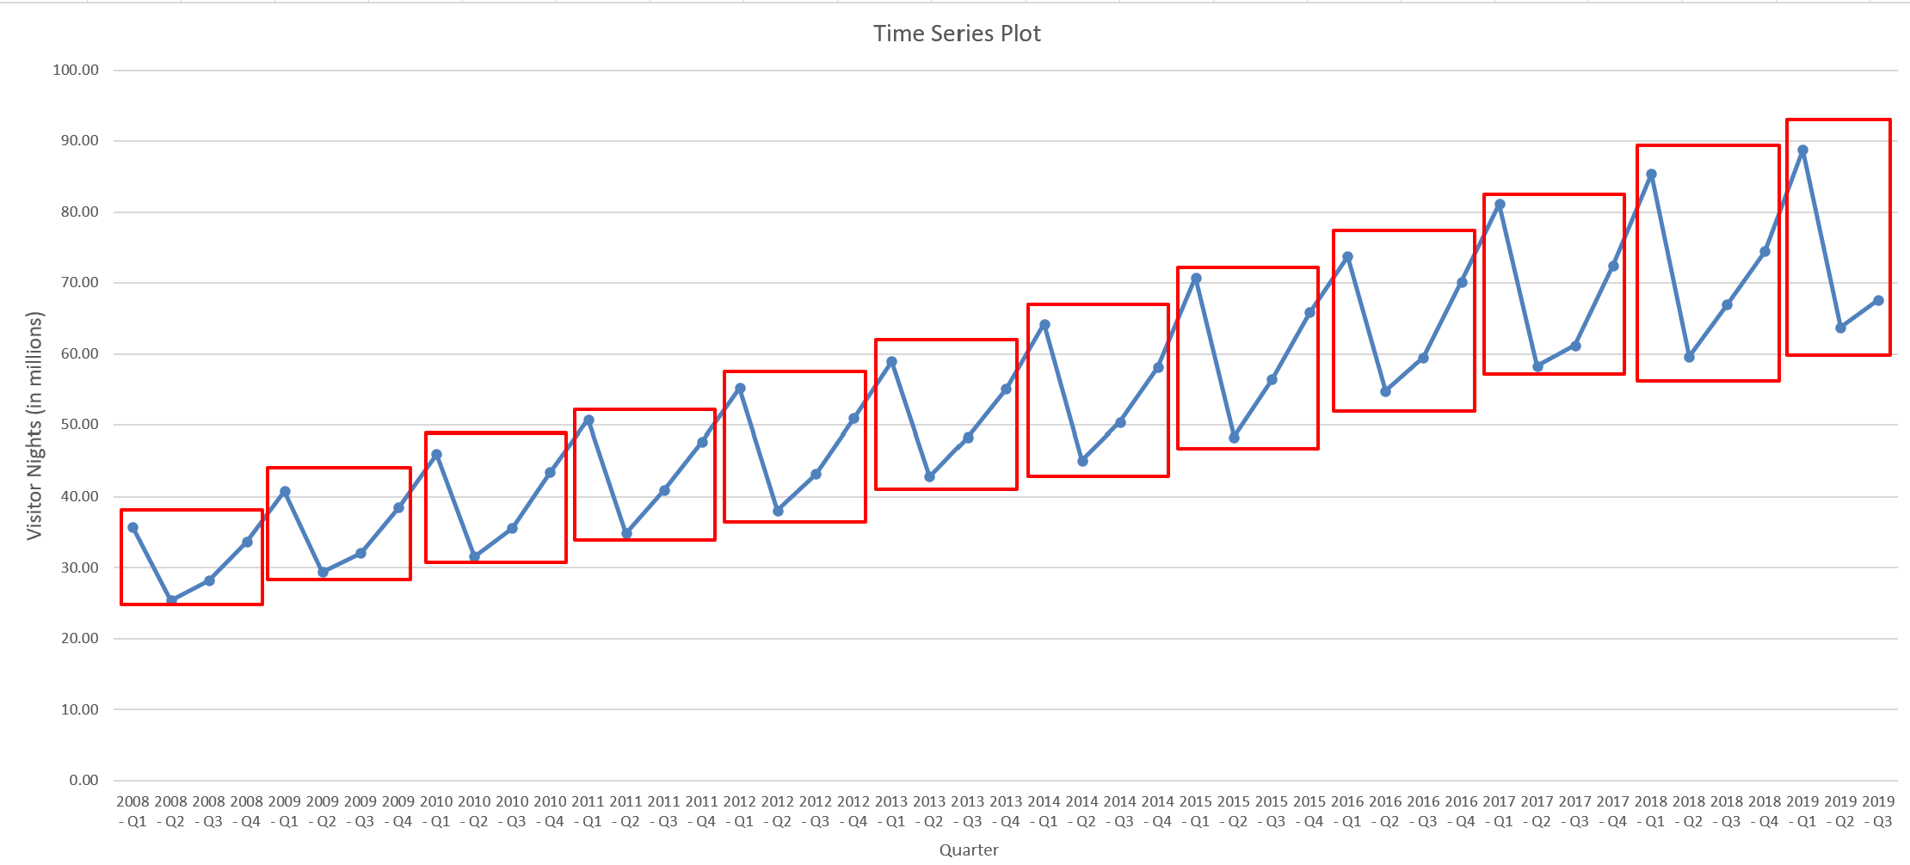

bi)
Naïve Method (MSE = 163.19)
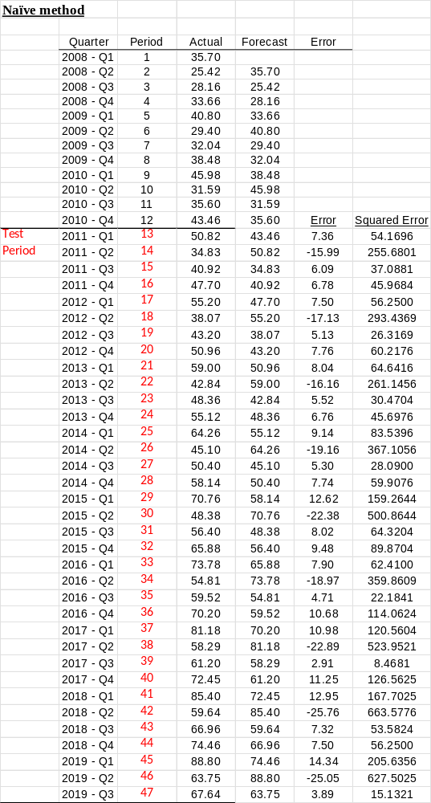

bii)
Holt’s Exponential Smoothing (MSE = 193.23)
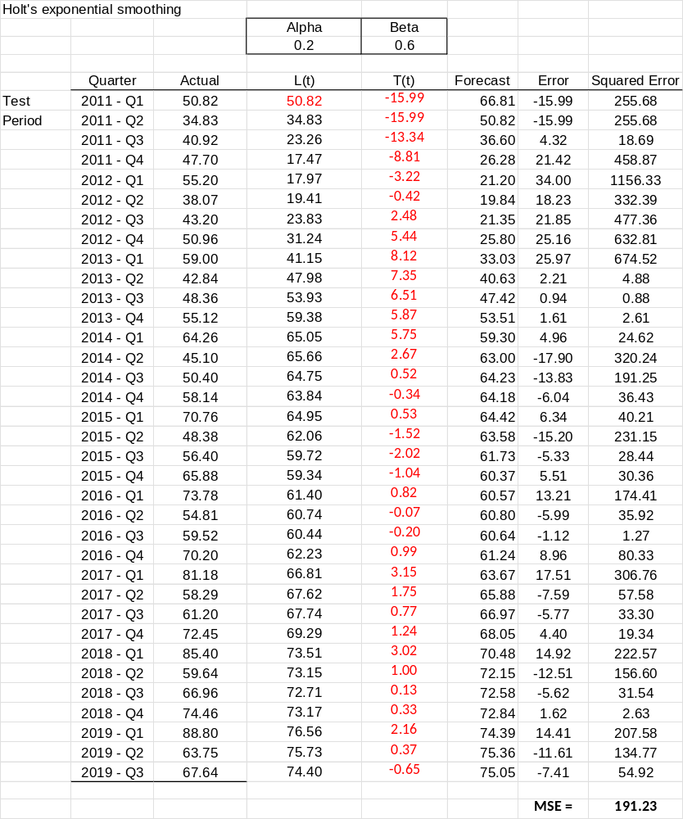

biii)
Winters’ Exponential Smoothing (MSE = 261491.49)
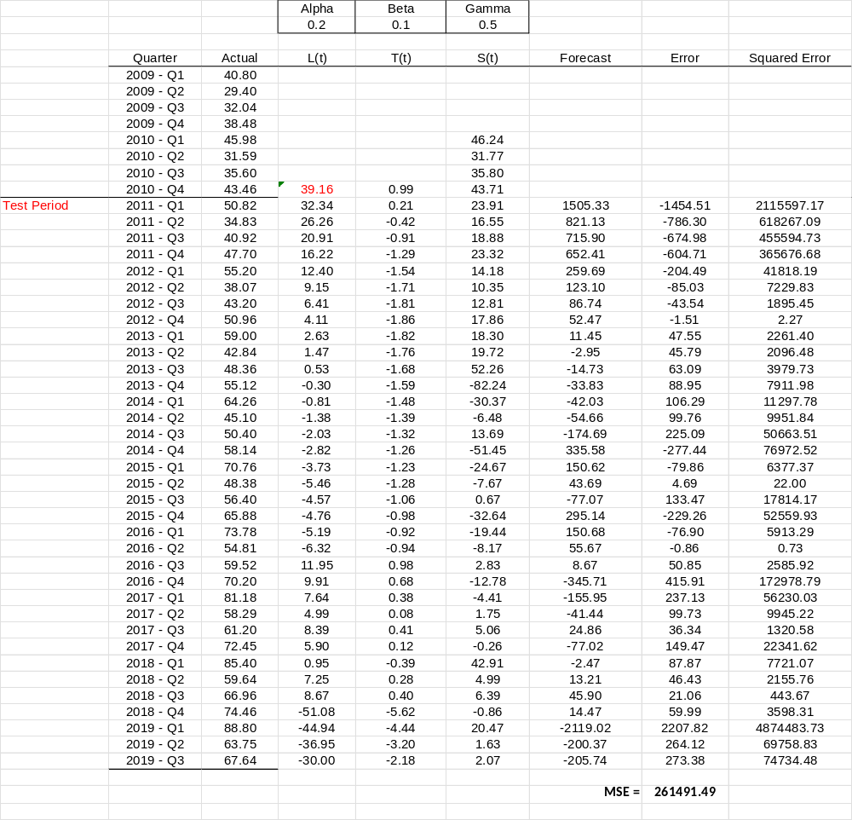

It is obvious that Winters’ method is the best method to forecast the sales in test periods 2011-Q1 to 2019-Q3 since it produced the smallest value of MSE.

